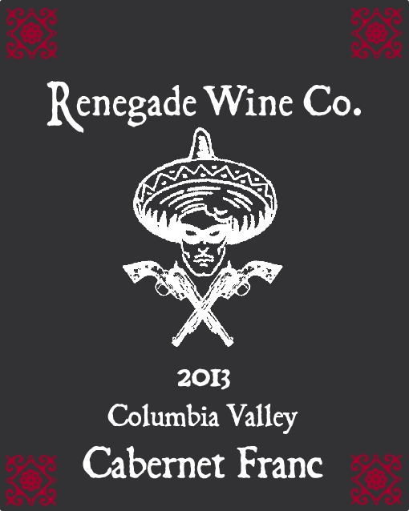

The Renegade Wine Co. is very excited to release the 2013 Columbia Valley Cabernet Franc. Less than 300 cases of this wine were produced, and after drinking a bottle, you’ll wish we made more! This Cab Franc was barrel aged for 16 months in two and three year old French oak barrels before bottling, All the classic Cab Franc characteristics are here, tobacco leaf, cocoa, red cherries, and a gorgeous layer of tannin to round out the rich mid palate. Like all the Renegade wines, this drinks as good as something twice as expensive. But you better pick this up soon, as it won’t sit on the shelf long….Only 295 cases produced.
Release date April 1st, 2015

